Here are window crank replacement parts:
https://www.windowrepairparts.us/shop/truth-crank-operator-stamped-40754/
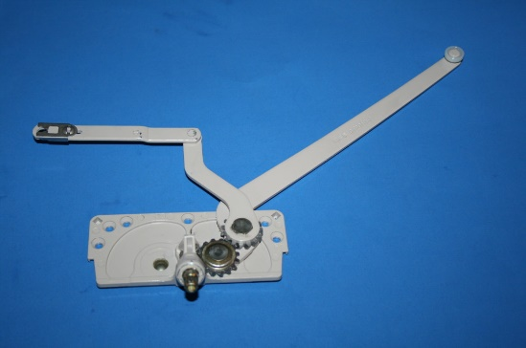 | Truth Crank Operator Stamped 40754 - Window Repair Parts  For cover and handle use 36-173CV For cover and handle is 37-137  www.windowrepairparts.us


https://www.windowrepairparts.us/shop/crank-handle/
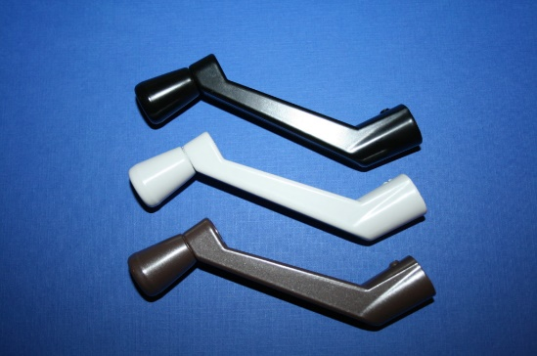 | Crank Handle 37-137 White ,Black, Bronze or Beige - Window Repair Parts  Crank Handle in White, Black or Bronze other colors available contact us for details. These are 3 1/2" x 2 9/64" with 11/32 spline  www.windowrepairparts.us

